
MODULE
WEB DESIGNING

PROJECT 2012

Marker’s comments:

Moderator’s comments:

Marks: Moderator Marks: Final Mark:


Statement and Confirmation of Own Work
Programme/Qualification name: International Diploma in Computer Studies
All NCC Education assessed assignments submitted by students must have this statement as the cover page or it will not be accepted for marking. Please ensure that this statement is either firmly attached to the cover of the assignment or electronically inserted into the front of the assignment.
Student declaration
I have read and understood NCC Education’s Policy on Academic Dishonesty and Plagiarism.
I can confirm the following details:
Student ID/Registration number : 00133244
Name : Abdul Bundu Kamara
Centre Name : IPMC
Module Name : Web Designing
Module Leader : MR. Isaac Annan
Number of words : 9,303
I confirm that this is my own work and that I have not plagiarised any part of it. I have also noted the assessment criteria and pass mark for assignments.
Due Date : 26 July 2012
Student Signature :
Submitted Date : 24 July 2012

Table of Contents

Contents--------------------------------------------------------------------------------------Page

Introduction…………………………………………………………………………………………………..5

Task 1………………………………………Research………………………………………………….6 - 7

Task 2……………………………………………Project Plan………………………………………8 - 10

Task 3……………………………………………Design Specification………………..………11 - 17

Task 4………………………………………………Website……………………………………..….18 - 66

Task 5……………………………………………Critical Evaluation……………………………67 - 69

References…………………………………………………………………………………………………….70

Bibliography…………………………………………………………………………………………………..70

ACKNOWLEDGEMENT
With honour, glory and praise I would first of all like to thank the Almighty God for making it possible for me to be able to complete this project assignment, I would also like to thank my sponsors (IMWCY) Women’s Division United Methodist Church, for their financial support towards my education of which has made it possible for me to have this great opportunity in this capacity. My special thanks to my mother for her continues support with love and careering to encourage me when hope is gone Mum I love you.
I would like to thank my able Lecturer Mr. Isaac Annan for his masterpiece quality support patience and directives in the assessment of this assignment which as help me incredibly in the compilation of the project work. Not forgetting to thank all of my friends in the Church and my Pastor and Congregation of the United Methodist Church Krisan Refugee Camp Ghana for their prayers and support.
Lastly thanks to everybody that have supported me in any way, may God bless you all. Amen.
Special Thanks to Madam Lisa H. Katzenstein of the Global Ministries UMC, may our good Lord continue to bless you and your entire family,a special place is reserved for people like you in Heaven. You have the eyes to see beyond and gave me the opportunity; words cannot express how grateful I am to the Lord for your life stay blessed you are always in my prayers.

Introduction
With their slim bodies and large colourful wings, butterflies are distinctive and popular insects.
Butterflies have an interesting lifecycle going through four stages: egg, larva, pupa and adult. There are thousands of different species and butterflies can be found all over the world, with many migrating long distances at certain times of the year. The larva produces a caterpillar which is considered a pest.
However, many adult butterflies play an important role in pollinating plants. In the UK it has long been known that butterfly populations are in decline, and in recent years there has been growing evidence that this is a global problem with numbers falling on every continent on the planet. Although the reasons for this decline aren’t entirely clear, destruction of the butterflies’ natural habitat and the increased use of pesticides are thought to play a significant role.

Task 1
Research
URL | SUMMARY
http://www.eurobutterflies.com/species_pages/palaemon.htm | This websites gives me a clear picture of various species of butterflies in Europe. In this website I am able to take a close look into the structure and colours of the butterflies. The colours and structures of butterflies give me an understanding to their beauty and functions on the environment.
http://www.monarch-butterfly.com/monarch-migration.html | The website gives me an understanding on a particular type of butterfly called Monarch butterfly that cannot survive extreme cold and habited mostly in United States during summer and migrate during October to other part in south and west each autumn.  This website helps me to understand characteristics of the Monarch butterfly and also help me to know the partner of migration of this particular specie of butterfly.
http://butterflywebsite.com/gallery/index.cfm | This website give me a number of different type of species which I can explore to understand the various type of butterflies and there behaviours and life circle.  I am able to understand most of the common butterfly species. E.g. are Paieridae Whites, Sulphers and Lycaedidae Coppers.
http://www.butterfly-conservation.org/text/20/join_butterfly_conservation.html | This Website helps me to know the sites (areas) of some special species of butterflies; their work parties and there seasons in various locations of sites in Britain.  This website also give me a scope of understand procedures to follow in terms of helping the conservation of butterflies.
http://www.ukbutterflies.co.uk/index.php | This website help me to understand the butterflies that have migrate and the one that have extinct.  I have been able to know different type of species of butterflies.  E.g. Hesperiidae Skippers, Papilionidae Swallowtails and Pieridae Whites  The layout of the website also let me understand the design layout of my own website.
http://www.nhc.ed.ac.uk/index.php?page=24.25.26 | This website gave me an understanding into the extant and extinct species of butterflies including the way This website help me to understand the butterflies that have migrated and the one that have extinct.  I have been able to know different type of species of butterflies.  E.g. Hesperiidae Skippers, Papilionidae Swallowtails and Pieridae Whites  The layout of the website also let me to understand the design layout of my own websitetheir way of immigrating and their seasonal visiting styles.
http://www.wwb.co.uk/shop/index.php/cPath/26 | This website helps me to know the different species that are for sales and research. This website gives me an understanding in to how to keep and develop butterflies in a special environment that can allow them to bred safely and establish them in the environment.
http://kidsbutterfly.org/coloringpages | This website gives understanding how to help children to study butterflies by assisting them to know the behaviours of butterflies, their habitation, structure and life circle which are a fundamental characteristics of their features.

Task 2
Project Plan
Tasks | DATE AND TIME |  |  | Resources
Tasks | Time Started | Time Finish | Duration | Resources
Task 1  Research  In this task I did research on various types of websites that introduce butterflies as fascinating creatures. | 08/05/2012 | 09/05/2012 | 2 Days | Internet
Task 2  Project Plan  In this Task I set up a plan and time table frame for the tasks that I will achieve from the time I will start to the end. | 14/05/2012 | 15/05/2012 | 2 Days | Microsoft Office Project
Task 3  Design Specification  In this task I will start the drawing of the plan and structure specification of the navigation of my prospective butterflies’ website. I used appropriate techniques, images and detail presentation to explain my website. | 21/05/2012 | 29/05/2012 | 1Week 4Days | Corel Draw 3  Concept Draw
Task 4  Web Site  In this task I will develop the website using XHTML 1.0 with a minimum of six inter-linked pages:  - A home page: - this will make it possible to navigate to other resources with an embedded video streaming player.  - A page about butterflies their habitation  - A page that describes the current status of butterflies in a global perspectives.  - A page that shows different species of butterflies and there spot and region in a table.  - A page with HTML forms for visitors of the website to be able to enter information about butterflies that have been spotted.  - A page that provides links to other websites that are connected to information about butterflies. | 04/06/2012 | 13/06/2012 | 4 Weeks | Note pad ++ Microsoft office, www.w3school.com
Task 5  Evaluation  I will write a report to analyse my website and highlight some of the strong and weak aspect of the site. I will make some suggestion for improvement and propose ideas for advance development. I will point out the principal techniques and technology that I use to develop the website and who my website can be upgraded by using CSS (cascading Style Sheets). | 16/07/2012 | 20/07/2012 | 5 Days | Microsoft Office,

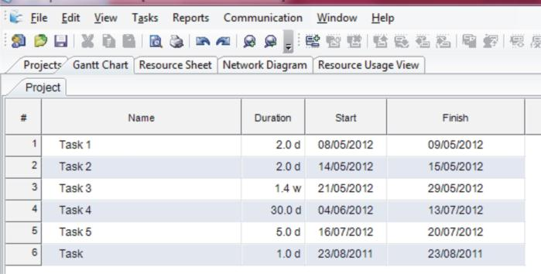
Project Timeline
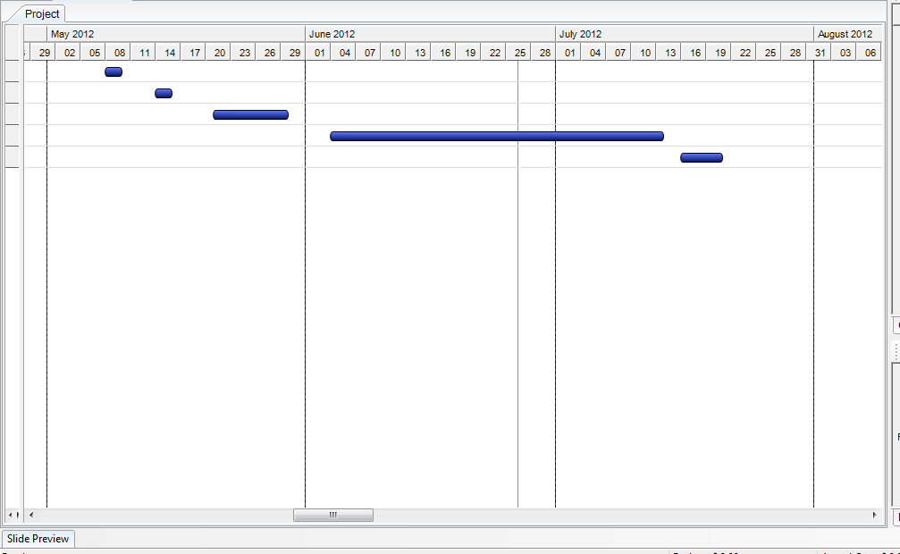

Task3
Design Specifications

Navigations Steps
This is the sitemap showing the plan for the design of my website on butterflies it shows the Butterfly website root folder that contains the buttons folder, image folder, video folder, Home page (Index) each of the sub-folders contain files format of their types.

Design Specifications
- Home Page
This is the home page; it displays the main navigation to other pages with a video embedded player to support playing of videos and text area for the viewing of text information. This page will describe the main purpose of the website and lead to other navigations to other pages on the site.

- Life Circle
This page displays some of the life style and life circle of a butterfly. It contains a picture gallery that shows photos of different stages of a butterfly life circle. This page will also give some of the descriptions of the stages of butterflies.

- Population Page
This page is about the population of extant and extinct butterflies and their major site and locations. This page will give a highlight of the cause of extinctions and what can help the extant of butterflies.

- Species Page
This page will speak about the different type of species and their sites how they survive and how their movement is like.

- Spotted
This web page gives a feedback form for users to give information on spotted species and give their locations.

- Links Page
This page give links to other resources of other website are available for more informations on butterflies.

Task 4
Website
Home Page Screen Shot
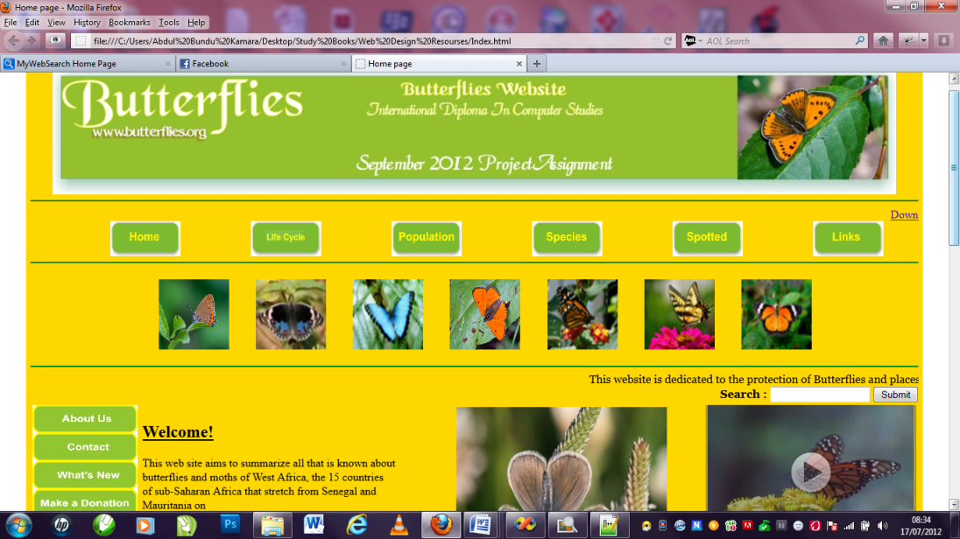
- This page show the user a clear backround of the purpose of the website it contain a video and navigation to all other pages of the website.

<!DOCTYPE html PUBLIC "-//W3C//DTD XHTML 1.0 Transitional//EN" "http://www.w3.org/TR/xhtml1/DTD/xhtml1-transitional.dtd">
<html xmlns="http://www.w3.org/1999/xhtml">
<head><title> Home page </title></head>

<body>

<table width="800" align="center" Cellpadding="3" cellspacing = "3" bgcolor="#FFD700" border ="0">
<tr>
<td width="1200" height="180" align ="center"><table width="1000" Cellspacing="3" cellpadding="3">
<tr height="180" align="center" ><img src = "../Web Design Resourses/Images/banner4.JPG" width="1200" height="180" align ="center"/></td>
</tr>
</table>
<hr color ="Green">
<div align ="right">
<a href = "#Down" valign ="top" align ="right">Down </a>
<div>

<table width = "1200" border="0" cellspacing="0" cellpadding="0" bgcolor ="">
<tr>
<td align="center"><a href ="Index.html"><img src ="../Web Design Resourses/Bottons/Home1.JPG" Width ="100" height ="50"/></a></td>
<td align="center"><a href ="../Web Design Resourses/Pages/Lifecircle.html"><img src ="../Web Design Resourses/Bottons/Lifecircle.JPG" Width ="100" height ="50"/></a></td>
<td align="center"><a href ="../Web Design Resourses/Pages/Population.html"><img src ="../Web Design Resourses/Bottons/Population.JPG" Width ="100" height ="50"/></a></td>
<td align="center"><a href ="../Web Design Resourses/Pages/Species.html"><img src ="../Web Design Resourses/Bottons/Species.JPG" Width ="100" height ="50"/></a></td>
<td align="center"><a href ="../Web Design Resourses/Pages/Spotted.html"><img src ="../Web Design Resourses/Bottons/Spotted.JPG" Width ="100" height ="50"/></a></td>
<td align="center"><a href ="../Web Design Resourses/Pages/Links.html"><img src ="../Web Design Resourses/Bottons/Links.JPG" Width ="100" height ="50"/></a></td>
</tr>
</table cellpadding = "0" cellspacing ="0">
<hr color ="Green" valign ="top">
<table Cellspacing="0" Cellpadding ="15" align ="center" bgcolor ="" width ="1000">
<tr>
<td>
<td height="100" align="center" valign="middle"><img src = "../Web Design Resourses/Images/butter.JPG" width="100" height="100"/></td>
<td height="100" align="center" valign="middle"><img src = "../Web Design Resourses/Images/butterfly1.JPG" width="100" height="100"/></td>
<td height="100" align="center" valign="middle"><img src = "../Web Design Resourses/Images/Butterfly2.JPG" width="100" height="100"/></td>
<td height="100" align="center" valign="middle"><img src = "../Web Design Resourses/Images/btfly.JPG" width="100" height="100"/></td>
<td height="100" align="center" valign="middle"><img src = "../Web Design Resourses/Images/Butterfly3.JPG" width="100" height="100"/></td>
<td height="100" align="center" valign="middle"><img src = "../Web Design Resourses/Images/butterfly4.JPG" width="100" height="100"/></td>
<td height="100" align="center" valign="middle"><img src = "../Web Design Resourses/Images/butterfly5.JPG" width="100" height="100"/></td>
</tr>
</table>
<hr color ="Green" />

<table width="1195" border="0" cellspacing="0" cellpadding="0" bgcolor ="" >
<tr>
<td align="center"><marquee behavior="scroll">
<font face="Georgia, Times New Roman, Times, serif"><font color="">This website is dedicated to the protection of Butterflies and places that they have been sited.
</font></font>
</marquee></td>
</tr>

<tr>
<td width="285" cellspacing ="0" cellpadding="0" align = "right"><form id="form1" name="form1" method="post" action="">
<b><font face="Georgia, Times New Roman, Times, serif">Search : </font></b>
<input type="text" name="textfield" />
<input type="submit" name="Submit" value="Submit" />
</form></td>
</tr>
</table>

<table width="1195" bgcolor="" align="center" height="1000" valign = "top" border ="0" >
<tr>
<td width="125" valign ="top">
<table width = "5" align ="center" cellspacing ="0" cellpadding="0" valign ="top">
<tr><td width ="5" height ="10"><img src ="../Web Design Resourses/Bottons/Aboutus.JPG" Width ="150" height ="40"/></td></tr>
<tr><td width ="5" height ="10"><img src ="../Web Design Resourses/Bottons/Contact.JPG" Width ="150" height ="40"/></td></tr>
<tr><td width ="5" height ="10"><img src ="../Web Design Resourses/Bottons/whatnew.JPG" Width ="150" height ="40"/></td></tr>
<tr><td width ="5" height ="10"><img src ="../Web Design Resourses/Bottons/Donation.JPG" Width ="150" height ="40"/></td></tr>
<tr><td width ="5" height ="10" ><img src ="../Web Design Resourses/Bottons/Coservation.JPG" Width ="150" height ="40"/></td></tr>
<tr><td width ="5" height ="10"><img src ="../Web Design Resourses/Bottons/Community.JPG" Width ="150" height ="40"/></</td></tr>
<tr><td width ="5" height ="10"><img src ="../Web Design Resourses/Bottons/Videos.JPG" Width ="150" height ="40"/></td></tr>
<tr><td width ="5" height ="10"><img src ="../Web Design Resourses/Bottons/Gallary.JPG" Width ="150" height ="40"/></td></tr>
</table>
</td>
<td width="800" valign = "top" align = "left"><table border ="0" width ="800" height ="800">
<td td width = "400" height="400" border ="1" valign ="top"><p><u><h2>Welcome!</h2></u>
This web site aims to summarize all that is known about<br> butterflies and moths of West Africa, the 15 countries<br>
of sub-Saharan Africa that stretch from Senegal and Mauritania on <br> the Atlantic to Niger and Nigeria in the east.
West Africa has been <br> earmarked as one of the world’s hotspots of biodiversity, because <br> its rainforests,
the Upper Guinean forests, are home to a <br> large number of animal and plant species occurring nowhere <br>
else on the earth’s surface. The peculiar flora <br> and fauna of this area can be attributed to its isolated position:<br>
the forests are separated from the rest of the African <br> rainforests by the Dahomey Gap, an extension of the <br>
woodland savannah of the Sahel to the Gulf of Guinea. </p>
<td width = "400" height="400" valign ="top" align ="center"><img src ="../Web Design Resourses/Images/fly.JPG" Width ="300" height ="300"/></td>
</tr>

<tr>
<td width = "400" height="400" valign ="top" align ="center"><img src ="../Web Design Resourses/Images/webfly.JPG" Width ="300" height ="300"/></td>
<td td width = "400" height="400" border ="0" valign ="top">
<p><u><h2>Introduction to the Important of Butterflies<br></h2></u>
Butterflies are a major, integral part of the forest ecology. <br> They are important specialized herbivores.
They play a role in pollination of many plants.<br> They are important prey to a varied assemblage of predators<br>
(rodents, birds, lizards, chamaeleons, mantids, assassin bugs, wasps, <br>
ants, robber-flies, dragonflies, crab-spiders, and orb-spinning spiders). <br>They are hosts to a plethora of parasites and parasitoids,
<br>some of which are themselves subject to hyper-parasitism.<br>
Many Lycaenidae live in complex and curious symbiotic relationships with ants.<br>
The web of life that surrounds butterflies is so varied and so complex <br>
that it seems safe to say that when essentially all butterflies still survive,
<br> this will be true also for much of the rest of forest biodiversity.</p>
</tr>
<tr>
<td align="center" colspan ="2"><marquee behavior="scroll">
<font face="Georgia, Times New Roman, Times, serif"><font color="#3366FF"><img src = "../Web Design Resourses/Images/safe.JPG" width="600" height="100"/></font></font>
</marquee></td>
</tr>
</table></td>

<td width="300" height="450" align="right" cellpadding = "0" cellspacing ="0" border ="1" valign ="top"><table>
<video controls = "True" width = "300" height ="220" valign ="top" cellpadding ="0" cellspacing ="0" align ="right">
<source src="../Web Design Resourses/Videos/Monarch1.mp4" type="video/mp4"/>
<source src="../Web Design Resourses/Videos/Monarch5.ogv" type="video/ogv" />
<source src="../Web Design Resourses/Videos/Monarch3.webm" type="video/webm" />
<object data="../Web Design Resourses/Videos/Monarch.SWF/" width="320" height="240">
<embed src ="../Web Design Resourses/Videos/Monarch.SWF/">
Your browser does not support video
</embed>
</object>
</video>
</td>
<tr><th> Social Links</th></tr>
<tr><td><a href ="https://www.facebook.com/pages/Butterfly-Conservation/109223272437586" target = "_blank"><img src ="../Web Design Resourses/Bottons/facebook.JPG" Width ="200" height ="50" align ="center" /></a></td></tr>
<tr><td><a href =" https://twitter.com/savebutterflies/status/217648895856082946" target ="_blank"><img src ="../Web Design Resourses/Bottons/twitter.JPG" Width ="200" height ="50" align ="center"/></a></td></tr>
<tr><td><a href="http://www.ukbutterflies.co.uk/index.php" Target ="_blank"><img src ="../Web Design Resourses/Bottons/ukbutterflies.JPG" Width ="200" height ="50" align ="center"/></a></td></tr>
</table>
</td>
</tr>
</table>
<a name ="Down" ></a><a href = "#top"> Back to the top</a>
<hr color = "green">
<table align="center" cellpadding = "0" cellspacing ="0"><tr><td valign ="bottom" align ="center" > All content copyright &copy; 2012, NCC Student Abdul Bunduk Kamara</td></tr></table>

</body>

</html>

Life Cycle Page Screen Shot
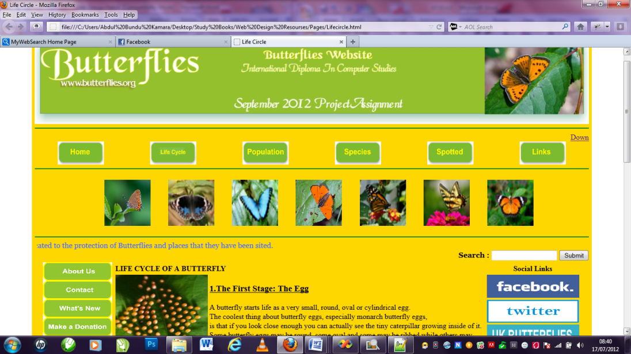
- This page give the user an understanding of the life cycle of a butter fly, the page shows picture of the steps that the butter fly takes to develop.

<!DOCTYPE html PUBLIC "-//W3C//DTD XHTML 1.0 Transitional//EN" "http://www.w3.org/TR/xhtml1/DTD/xhtml1-transitional.dtd">
<html xmlns="http://www.w3.org/1999/xhtml">

<head><title> Life Circle</title></head>

<body>

<table width="800" align="center" Cellpadding="3" cellspacing = "3" bgcolor="#FFD700" border ="0">

<div align = "center" id= "header">
<tr>
<td width="1200" height="180" align ="center"><table width="1000" Cellspacing="3" cellpadding="3">
<tr height="180" align="center"><img src = "../Images/banner4.JPG" width="1200" height="180"/></td>
</tr>
</div>
</table>
<hr color ="Green">
<div align ="right">
<a href = "#Down" valign ="top" align ="right">Down </a>
<div>

<table width = "1200" border="0" cellspacing="0" cellpadding="0" bgcolor ="">
<tr>
<td align="center"><a href ="../Index.html"><img src ="../Bottons/Home1.JPG" Width ="100" height ="50"/></a></td>
<td align="center"><a href ="Lifecircle.html"><img src ="../Bottons/Lifecircle.JPG" Width ="100" height ="50"/></a></td>
<td align="center"><a href ="Population.html"><img src ="../Bottons/Population.JPG" Width ="100" height ="50"/></a></td>
<td align="center"><a href ="Species.html"><img src ="../Bottons/Species.JPG" Width ="100" height ="50"/></a></td>
<td align="center"><a href ="Spotted.html"><img src ="../Bottons/Spotted.JPG" Width ="100" height ="50"/></a></td>
<td align="center"><a href ="Links.html"><img src ="../Bottons/Links.JPG" Width ="100" height ="50"/></a></td>
</tr>
</table cellpadding = "0" cellspacing ="0" >
<hr color ="Green" valign ="top">
<table Cellspacing="0" Cellpadding ="15" align ="center" bgcolor ="" width ="1000">
<tr>
<td>
<td height="100" align="center" valign="middle"><img src = "../Images/butter.JPG" width="100" height="100"/></td>
<td height="100" align="center" valign="middle"><img src = "../Images/butterfly1.JPG" width="100" height="100"/></td>
<td height="100" align="center" valign="middle"><img src = "../Images/Butterfly2.JPG" width="100" height="100"/></td>
<td height="100" align="center" valign="middle"><img src = "../Images/btfly.JPG" width="100" height="100"/></td>
<td height="100" align="center" valign="middle"><img src = "../Images/Butterfly3.JPG" width="100" height="100"/></td>
<td height="100" align="center" valign="middle"><img src = "../Images/butterfly4.JPG" width="100" height="100"/></td>
<td height="100" align="center" valign="middle"><img src = "../Images/butterfly5.JPG" width="100" height="100"/></td>
</tr>
</table>
<hr color ="Green" />

<table width="1195" border="0" cellspacing="0" cellpadding="0" bgcolor ="#FFD700" >
<tr>
<td align="center"><marquee behavior="scroll">
<font face="Georgia, Times New Roman, Times, serif"><font color="#3366FF">This website is dedicated to the protection of Butterflies and places that they have been sited.
</font></font>
</marquee></td>
</tr>

<tr>
<td width="285" cellspacing ="0" cellpadding="0" align = "right"><form id="form1" name="form1" method="post" action="">
<b><font face="Georgia, Times New Roman, Times, serif">Search : </font></b>
<input type="text" name="textfield" />
<input type="submit" name="Submit" value="Submit" />
</form></td>
</tr>
</table>

<table width="1000" bgcolor="" align="center" height="1000" valign = "top" border ="0" >
<tr>
<td width="125" valign ="top">
<table width = "5" align ="center" cellspacing ="0" cellpadding="0" valign ="top">
<tr><td width ="5" height ="10"><img src ="../Bottons/Aboutus.JPG" Width ="150" height ="40"/></td></tr>
<tr><td width ="5" height ="10"><img src ="../Bottons/Contact.JPG" Width ="150" height ="40"/></td></tr>
<tr><td width ="5" height ="10"><img src ="../Bottons/whatnew.JPG" Width ="150" height ="40"/></td></tr>
<tr><td width ="5" height ="10"><img src ="../Bottons/Donation.JPG" Width ="150" height ="40"/></td></tr>
<tr><td width ="5" height ="10" ><img src ="../Bottons/Coservation.JPG" Width ="150" height ="40"/></td></tr>
<tr><td width ="5" height ="10"><img src ="../Bottons/Community.JPG" Width ="150" height ="40"/></</td></tr>
<tr><td width ="5" height ="10"><img src ="../Bottons/Videos.JPG" Width ="150" height ="40"/></td></tr>
<tr><td width ="5" height ="10"><img src ="../Bottons/Gallary.JPG" Width ="150" height ="40"/></td></tr>
</table>
</td>
<td width="650" valign = "top" align = "left"><table border ="0" width ="800" >
<tr><em><th colspan ="2">LIFE CYCLE OF A BUTTERFLY </th></em></tr>
<tr>
<td height="200" align="center" valign="top" width ="200"><img src = "../Images/eggs.JPG" width="200" height="200"/></td>
<td valign ="top"><u><h3> 1.The First Stage: The Egg</h3></u>
A butterfly starts life as a very small, round, oval or cylindrical egg.<br>
The coolest thing about butterfly eggs, especially monarch butterfly eggs, <br>
is that if you look close enough you can actually see the tiny caterpillar growing inside of it. <br>
Some butterfly eggs may be round, some oval and some may be ribbed while others may have<br>
other features. The egg shape depends on the type of butterfly that laid the egg. </td>
</tr>
<tr>
<td height="200" align="center" valign="top" width ="200"><img src = "../Images/Caterpillar.JPG" width="200" height="200"/></td>
<td valign ="top">
<u><h3>2.The Second Stage: The Larva (Caterpillar) </h3></u>
When the egg finally hatches, most of you would expect for a butterfly to emerge, right?<br>
Well, not exactly. In the butterfly’s life cycle, there are four stages and this <br>
is only the second stage.Butterfly larvae are actually what we call caterpillars. <br>
Caterpillars do not stay in this stage for very long and mostly, in this stage all they do is eat.
</td>
</tr>
<tr>
<td height="200" align="center" valign="top" width ="200"><img src = "../Images/Pupa.JPG" width="200" height="200"/></td>
<td valign ="top">
<u><h3>3.The Third Stage: Pupa (Chrysalis) </h3></u>
Monarch Caterpillar Becoming a Chrysalis The pupa stage is one of the coolest stages of a butterfly’s life.<br>
As soon as a caterpillar is done growing and they have reached their full length/weight, <br>
they form themselves into a pupa, also known as a chrysalis. <br>
From the outside of the pupa, it looks as if the caterpillar may just be resting, <br>
but the inside is where all of the action is. Inside of the pupa, the caterpillar is rapidly changing. <br>
</td>
</tr>
<tr>
<td height="200" align="center" valign="top" width ="200"><img src = "../Images/butter-emerging.JPG" width="200" height="200"/></td>
<td valign ="top">
<u><h3>4.The Fourth Stage: Adult Butterfly </h3></u>
Watch a Monarch Hatching Finally, when the caterpillar has done all of its forming and <br>
changing inside the pupa,if you are lucky, you will get to see an adult butterfly emerge. <br>
When the butterfly first emerges from the chrysalis, both of the wings are going to be soft <br>
and folded against its body. This is because the butterfly had to fit all its new parts <br>
inside of the pupa.
</td>
</tr>
<tr>
<td align="center" colspan ="2"><marquee behavior="scroll">
<font face="Georgia, Times New Roman, Times, serif"><font color="#3366FF"><img src = "../Images/safe.JPG" width="600" height="100"/></font></font>
</marquee></td>
</tr>
</table></td>

<td width="450" height="450" align="right" cellpadding = "0" cellspacing ="0" border ="1" valign ="top"><table>

</td>
<tr><th> Social Links</th></tr>
<tr><td><a href ="https://www.facebook.com/pages/Butterfly-Conservation/109223272437586" target = "_blank"><img src ="../Bottons/facebook.JPG" Width ="200" height ="50" align ="center" /></a></td></tr>
<tr><td><a href =" https://twitter.com/savebutterflies/status/217648895856082946" target ="_blank"><img src ="../Bottons/twitter.JPG" Width ="200" height ="50" align ="center"/></a></td></tr>
<tr><td><a href="http://www.ukbutterflies.co.uk/index.php" Target ="_blank"><img src ="../Bottons/ukbutterflies.JPG" Width ="200" height ="50" align ="center"/></a></td></tr>
</table>
</td>
</tr>
</table>
<a name ="Down" ></a><a href = "#top"> Back to the top</a>
<hr color = "green">
<table align="center" cellpadding = "0" cellspacing ="0"><tr><td valign ="bottom" align ="center" > All content copyright &copy; 2012, NCC Student Abdul Bunduk Kamara</td></tr></table>

</body>

</html>

Population Page Screen Shot
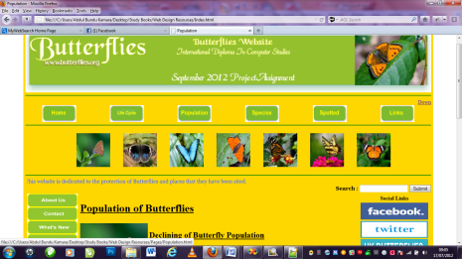
- This page talks about the population of the butter fly and how environmental degradation has cause the decline of some of this species.

<!DOCTYPE html PUBLIC "-//W3C//DTD XHTML 1.0 Transitional//EN" "http://www.w3.org/TR/xhtml1/DTD/xhtml1-transitional.dtd">
<html xmlns="http://www.w3.org/1999/xhtml">
<head><title> Population </title></head>

<body>

<table width="800" align="center" Cellpadding="3" cellspacing = "3" bgcolor="#FFD700" border ="0">
<tr>
<td width="1200" height="180" align ="center"><table width="1000" Cellspacing="3" cellpadding="3">
<tr height="180" align="center"><img src = "../Images/banner4.JPG" width="1200" height="180"/></td>
</tr>
</table>
<hr color ="Green">
<div align ="right">
<a href = "#Down" valign ="top" align ="right">Down </a>
<div>

<table width = "1200" border="0" cellspacing="0" cellpadding="0" bgcolor ="">
<tr>
<td align="center"><a href ="../Index.html"><img src ="../Bottons/Home1.JPG" Width ="100" height ="50"/></a></td>
<td align="center"><a href ="Lifecircle.html"><img src ="../Bottons/Lifecircle.JPG" Width ="100" height ="50"/></a></td>
<td align="center"><a href ="Population.html"><img src ="../Bottons/Population.JPG" Width ="100" height ="50"/></a></td>
<td align="center"><a href ="Species.html"><img src ="../Bottons/Species.JPG" Width ="100" height ="50"/></a></td>
<td align="center"><a href ="Spotted.html"><img src ="../Bottons/Spotted.JPG" Width ="100" height ="50"/></a></td>
<td align="center"><a href ="Links.html"><img src ="../Bottons/Links.JPG" Width ="100" height ="50"/></a></td>
</tr>
</table cellpadding = "0" cellspacing ="0" >
<hr color ="Green" valign ="top">
<table Cellspacing="0" Cellpadding ="15" align ="center" bgcolor ="" width ="1000">
<tr>
<td>
<td height="100" align="center" valign="middle"><img src = "../Images/butter.JPG" width="100" height="100"/></td>
<td height="100" align="center" valign="middle"><img src = "../Images/butterfly1.JPG" width="100" height="100"/></td>
<td height="100" align="center" valign="middle"><img src = "../Images/Butterfly2.JPG" width="100" height="100"/></td>
<td height="100" align="center" valign="middle"><img src = "../Images/btfly.JPG" width="100" height="100"/></td>
<td height="100" align="center" valign="middle"><img src = "../Images/Butterfly3.JPG" width="100" height="100"/></td>
<td height="100" align="center" valign="middle"><img src = "../Images/butterfly4.JPG" width="100" height="100"/></td>
<td height="100" align="center" valign="middle"><img src = "../Images/butterfly5.JPG" width="100" height="100"/></td>
</tr>
</table>
<hr color ="Green" />

<table width="1195" border="0" cellspacing="0" cellpadding="0" bgcolor ="#FFD700" >
<tr>
<td align="center"><marquee behavior="scroll">
<font face="Georgia, Times New Roman, Times, serif"><font color="#3366FF">This website is dedicated to the protection of Butterflies and places that they have been sited.
</font></font>
</marquee></td>
</tr>

<tr>
<td width="285" cellspacing ="0" cellpadding="0" align = "right"><form id="form1" name="form1" method="post" action="">
<b><font face="Georgia, Times New Roman, Times, serif">Search : </font></b>
<input type="text" name="textfield" />
<input type="submit" name="Submit" value="Submit" />
</form></td>
</tr>
</table>

<table width="1195" bgcolor="" align="center" height="1000" valign = "top" border ="0" >
<tr>
<td width="125" valign ="top">
<table width = "5" align ="center" cellspacing ="0" cellpadding="0" valign ="top">
<tr><td width ="5" height ="10"><img src ="../Bottons/Aboutus.JPG" Width ="150" height ="40"/></td></tr>
<tr><td width ="5" height ="10"><img src ="../Bottons/Contact.JPG" Width ="150" height ="40"/></td></tr>
<tr><td width ="5" height ="10"><img src ="../Bottons/whatnew.JPG" Width ="150" height ="40"/></td></tr>
<tr><td width ="5" height ="10"><img src ="../Bottons/Donation.JPG" Width ="150" height ="40"/></td></tr>
<tr><td width ="5" height ="10" ><img src ="../Bottons/Coservation.JPG" Width ="150" height ="40"/></td></tr>
<tr><td width ="5" height ="10"><img src ="../Bottons/Community.JPG" Width ="150" height ="40"/></</td></tr>
<tr><td width ="5" height ="10"><img src ="../Bottons/Videos.JPG" Width ="150" height ="40"/></td></tr>
<tr><td width ="5" height ="10"><img src ="../Bottons/Gallary.JPG" Width ="150" height ="40"/></td></tr>
</table>
</td>
<td width="650" valign = "top" align = "left"><table border ="0" width ="800" >
<tr><em><th colspan ="2"><u><h1>Population of Butterflies</h1></u></th></em></tr>
<tr>
<td height="200" align="center" valign="top" width ="200" cellspacing ="2" cellpadding="2"><img src = "../Images/butter.JPG" width="200" height="200"/></td>
<td valign ="top" ><p><u><h2> Declining of Butterfly Population</h2></u>
Hundreds of butterflies, beetles and dragonflies are at risk of extinction<br>
across In Africa with almost one-third of 435 butterfly species in decline,<br>
scientists have warned.</p>
</td>
</tr>
<tr>
<td height="200" align="center" valign="top" width ="200"><img src = "../Images/btfly.JPG" width="200" height="200"/></td>
<td valign ="top">
The loss of habitat caused by intensive deforestation, climate change, forest
<br> fires and the expansion of urbanasation is threatening with
<br>extinction 14% of dragonflies, 11% of saproxylic beetles and 9% of
<br>butterflies within Africa, according to World report.
</td>
</tr>
<tr>
<td height="200" align="center" valign="top" width ="200"><img src = "../Images/fly.JPG" width="200" height="200"/></td>
<td valign ="top"><u><h3>Discussion</h3></u>
"When talking about threatened species, people tend to think of larger, more<br>
charismatic creatures such as pandas or tigers, but we mustn't forget that the<br>
small species on our planet are just as important," said Jane Smart of <br>
the International Union for Conservation of Nature (IUCN),<br>
the conservation group which produced the report.<br>
"Butterflies, for instance, play a hugely pivotal role as pollinators<br>
in the ecosystems in which they live."</p>
</td>
</tr>
</table></td>

<td width="450" height="450" align="right" cellpadding = "0" cellspacing ="0" border ="1" valign ="top"><table>

</td>
<tr><th> Social Links</th></tr>
<tr><td><a href ="https://www.facebook.com/pages/Butterfly-Conservation/109223272437586" target = "_blank"><img src ="../Bottons/facebook.JPG" Width ="200" height ="50" align ="center" /></a></td></tr>
<tr><td><a href =" https://twitter.com/savebutterflies/status/217648895856082946" target ="_blank"><img src ="../Bottons/twitter.JPG" Width ="200" height ="50" align ="center"/></a></td></tr>
<tr><td><a href="http://www.ukbutterflies.co.uk/index.php" Target ="_blank"><img src ="../Bottons/ukbutterflies.JPG" Width ="200" height ="50" align ="center"/></a></td></tr>
</table>
</td>
</tr>
<tr>
<td align="center" colspan ="3"><marquee behavior="scroll">
<font face="Georgia, Times New Roman, Times, serif"><font color="#3366FF"><img src = "../Images/safe.JPG" width="600" height="100"/></font></font>
</marquee></td>
</tr>
</table>
<a name ="Down" ></a><a href = "#top"> Back to the top</a>
<hr color = "green">
<table align="center" cellpadding = "0" cellspacing ="0"><tr><td valign ="bottom" align ="center" > All content copyright &copy; 2012, NCC Student Abdul Bunduk Kamara</td></tr></table>

</body>

</html>

Species Page Screen Shot
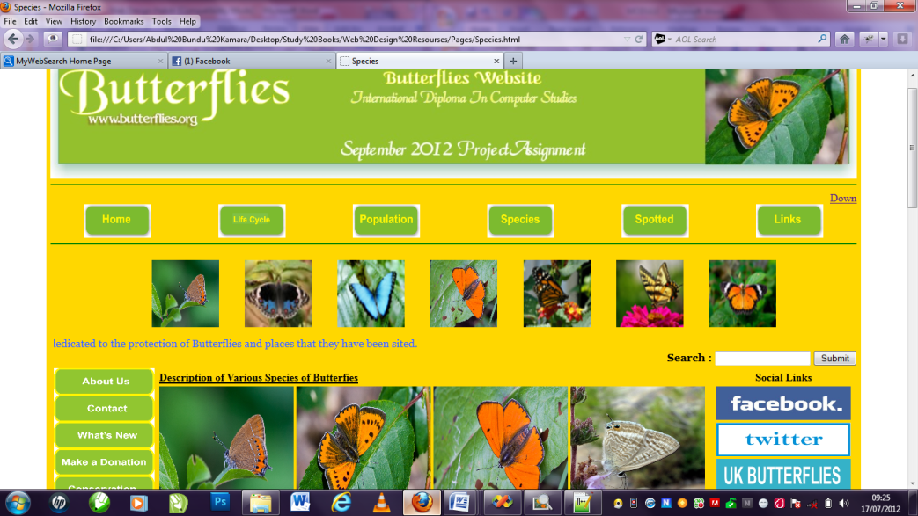
- This page gives a brief description of various types of butter flies.

<!DOCTYPE html PUBLIC "-//W3C//DTD XHTML 1.0 Transitional//EN" "http://www.w3.org/TR/xhtml1/DTD/xhtml1-transitional.dtd">
<html xmlns="http://www.w3.org/1999/xhtml">

<head><title> Species </title></head>

<body>

<table width="800" align="center" Cellpadding="3" cellspacing = "3" bgcolor="#FFD700" border ="0">
<tr>
<td width="1200" height="180" align ="center"><table width="1000" Cellspacing="3" cellpadding="3">
<tr height="180" align="center"><img src = "../Images/banner4.JPG" width="1200" height="180"/></td>
</tr>
</table>
<hr color ="Green">
<div align ="right">
<a href = "#Down" valign ="top" align ="right">Down </a>
<div>
<table width = "1200" border="0" cellspacing="0" cellpadding="0" bgcolor ="">
<tr>
<td align="center"><a href ="../Index.html"><img src ="../Bottons/Home1.JPG" Width ="100" height ="50"/></a></td>
<td align="center"><a href ="Lifecircle.html"><img src ="../Bottons/Lifecircle.JPG" Width ="100" height ="50"/></a></td>
<td align="center"><a href ="Population.html"><img src ="../Bottons/Population.JPG" Width ="100" height ="50"/></a></td>
<td align="center"><a href ="Species.html"><img src ="../Bottons/Species.JPG" Width ="100" height ="50"/></a></td>
<td align="center"><a href ="Spotted.html"><img src ="../Bottons/Spotted.JPG" Width ="100" height ="50"/></a></td>
<td align="center"><a href ="Links.html"><img src ="../Bottons/Links.JPG" Width ="100" height ="50"/></a></td>
</tr>
</table cellpadding = "0" cellspacing ="0" >
<hr color ="Green" valign ="top">
<table Cellspacing="0" Cellpadding ="15" align ="center" bgcolor ="" width ="1000">
<tr>
<td>
<td height="100" align="center" valign="middle"><img src = "../Images/butter.JPG" width="100" height="100"/></td>
<td height="100" align="center" valign="middle"><img src = "../Images/butterfly1.JPG" width="100" height="100"/></td>
<td height="100" align="center" valign="middle"><img src = "../Images/Butterfly2.JPG" width="100" height="100"/></td>
<td height="100" align="center" valign="middle"><img src = "../Images/btfly.JPG" width="100" height="100"/></td>
<td height="100" align="center" valign="middle"><img src = "../Images/Butterfly3.JPG" width="100" height="100"/></td>
<td height="100" align="center" valign="middle"><img src = "../Images/butterfly4.JPG" width="100" height="100"/></td>
<td height="100" align="center" valign="middle"><img src = "../Images/butterfly5.JPG" width="100" height="100"/></td>
</tr>
</table>
<table width="1195" border="0" cellspacing="0" cellpadding="0" bgcolor ="" >
<tr>
<td align="center"><marquee behavior="scroll">
<font face="Georgia, Times New Roman, Times, serif"><font color="#3366FF">This website is dedicated to the protection of Butterflies and places that they have been sited.
</font></font>
</marquee></td>
</tr>

<tr>
<td width="285" cellspacing ="0" cellpadding="0" align = "right"><form id="form1" name="form1" method="post" action="">
<b><font face="Georgia, Times New Roman, Times, serif">Search : </font></b>
<input type="text" name="textfield" />
<input type="submit" name="Submit" value="Submit" />
</form></td>
</tr>
</table>

<table width="1195" bgcolor="" align="center" height="1000" valign = "top" border ="0" >
<tr>
<td width="125" valign ="top">
<table width = "5" align ="center" cellspacing ="0" cellpadding="0" valign ="top">
<tr><td width ="5" height ="10"><img src ="../Bottons/Aboutus.JPG" Width ="150" height ="40"/></td></tr>
<tr><td width ="5" height ="10"><img src ="../Bottons/Contact.JPG" Width ="150" height ="40"/></td></tr>
<tr><td width ="5" height ="10"><img src ="../Bottons/whatnew.JPG" Width ="150" height ="40"/></td></tr>
<tr><td width ="5" height ="10"><img src ="../Bottons/Donation.JPG" Width ="150" height ="40"/></td></tr>
<tr><td width ="5" height ="10" ><img src ="../Bottons/Coservation.JPG" Width ="150" height ="40"/></td></tr>
<tr><td width ="5" height ="10"><img src ="../Bottons/Community.JPG" Width ="150" height ="40"/></</td></tr>
<tr><td width ="5" height ="10"><img src ="../Bottons/Videos.JPG" Width ="150" height ="40"/></td></tr>
<tr><td width ="5" height ="10"><img src ="../Bottons/Gallary.JPG" Width ="150" height ="40"/></td></tr>
</table>
</td>
<td width="650" valign = "top" align = "left"><table border ="0" height ="1000" width ="800">
<tr>
<th colspan ="4" height ="10"><u>Description of Various Species of Butterfies</u></th>

</tr>
<tr>
<td width = "200" height="250" valign ="top" align ="left"><img src = "../Images/butter.JPG" width="200" height="200"/><br>
Larvae live solitarily on<br>
Stinging Nettle and grow faster on<br>
Elm or Osier Willow.Garden butterflies <br>
are going to be scarce this year. <br>
<td width = "200" height="250" valign ="top" align ="left"><img src ="../Images/bltfly.JPG" Width ="200" height ="200"/><br>
Larvae ready now. Feed<br>
on Clover, Trefoils, Medic, <br>
Vetches. Fast growing. <br>
Best kept sleeved <br>
on potted plants <br>
</td>
<td width = "200" height="250" valign ="top" align ="left" ><img src ="../Images/btfly.JPG" Width ="200" height ="200"/><br>
Fast growing and easy to rear on <br>
Stinging Nettle. Becoming scarcer,<br>
you can help boost local populations
</td>
<td width = "200" height="250" valign ="top" align ="left"><img src ="../Images/btnfly.JPG" Width ="200" height ="200"/><br>
<em>Pieris brassicae</em><br>
No longer the common <br>
butterfly it once was.<br>
Pupae are stored cool for<br>
the winter and normally hatch in May. <br>
</td>
</tr>
<tr>
<td width = "200" height="250" valign ="top" align ="left"><img src ="../Images/flies.JPG" Width ="200" height ="200"/><br>
<u>Family: Hesperiidae</u><br>
<u>Subfamily: Pyrginae</u>
Identification: Long tails. <br>
Upperside is dark blackish brown;<br>
body and wing bases are<br>
iridescent blue-green. <br>
Males have a costal fold enclosing<br>
scent scales on the forewing.

</td>
<td width = "200" height="250" valign ="top" align ="left"><img src ="../Images/fly.JPG" Width ="200" height ="200"/>

<u>Family: Hesperiidae</u><br>
<u>Subfamily: Pyrginae</u><br>
Identification: Tailless.<br>
Upperside of wings is dark <br>
brown with faint black bands.<br>
Lower tip of hindwing has wide yellow<br>
edging above and below.<br>
Wing Span: 2 - 2 1/2 inches (5.1 - 6.4 cm).
</td>
<td width = "200" height="250" valign ="top" align ="left"><img src ="../Images/uk butterfly.JPG" Width ="200" height ="200"/>
<u>Family: Hesperiidae</u><br>
<u>Subfamily: Pyrginae</u><br>
Identification: Tails are long; <br>
body and wings are brown. <br>
Forewing of both sexes has a <br>
thin transparent median band;<br>
male also has 5 transparent<br>
spots at the costal margin.<br>
Male has no costal fold.<br>
Wing Span: 1 5/16 - 1 1/2 inches (3.3 - 3.8 cm).

</td>
<td width = "200" height="250" valign ="top" align ="left"><img src ="../Images/ukbbfly.JPG" Width ="200" height ="200"/>

<u>Family: Hesperiidae</u><br>
<u>Subfamily: Pyrginae</u><br>
Identification: Tailless; wings are black<br>
with no white spots. <br>
Upperside wing bases are iridescent blue. <br>
Underside of hindwing has frosted <br>
white margin and white fringe.<br>
Wing Span: 2 - 2 1/2 inches (5.1 - 6.4 cm).

</td>
</tr>
<tr>
<td width = "200" height="250" valign ="top" align ="left"><img src ="../Images/ukbfly.JPG" Width ="200" height ="200"/>
<u>Family: Hesperiidae</u><br>
<u>Subfamily: Pyrginae</u><br>
Identification: Fringes are checkered.<br>
Upperside is slate gray with a<br>
wide white band on each wing;<br>
many small white spots <br>
on outer third of wings. <br>
Underside is dull yellowish <br>
brown with whitish spots.<br>
Wing Span: 1 1/8 - 1 3/8 inches (2.9 - 3.5 cm).

</td>
<td width = "200" height="250" valign ="top" align ="left"><img src ="../Images/webfly.JPG" Width ="200" height ="200"/>
<u>Family: Hesperiidae</u><br>
<u>Subfamily: Pyrginae</u><br>
Identification: Fringes are white.<br>
Upperside is black with green<br>
rays leading from the wing bases.<br>
Underside is black with a red and orang<br>
bar at the costal edge.<br>
Wing Span: 1 5/8 - 2 1/2 inches (4.2 - 6.3 cm).

</td>
<td width = "200" height="250" valign ="top" align ="left"><img src ="../Images/webfly1.JPG" Width ="200" height ="200"/>
<u>Family: Hesperiidae</u><br>
<u>Subfamily: Hesperiinae</u><br>
Identification: Upperside is dark brown.<br>
Underside of forewing is <br>
reddish with a gray<br>
patch at the tip and a <br>
white spot on the leading edge.<br>
Underside of hindwing has 2 gray bands.<br>
Wing Span: 3/4 - 7/8 inches (1.9 - 2.2 cm).

</td>
<td width = "200" height="250" valign ="top" align ="left"><img src ="../Images/webfly2.JPG" Width ="200" height ="200"/>

<u>Family: Hesperiidae</u><br>
<u>Subfamily: Pyrginae</u><br>
Identification: Hindwing with<br>
a very long tail. <br>
Wings are dark brown;<br>
forewing with large pale spots. <br>
Underside of hindwing has<br>
a long silver-white band <br>
from the costa to the base of the tail.<br>
Wing Span: 1 1/2 - 2 1/8 inches (3.9 - 5.4 cm).

</td>
</tr>
<tr>
<td align="center" colspan ="4"><marquee behavior="scroll">
<font face="Georgia, Times New Roman, Times, serif"><font color="#3366FF"><img src = "../Images/safe.JPG" width="600" height="100"/></font></font>
</marquee></td>
</tr>

</table></td>

<td width="450" height="450" align="right" cellpadding = "0" cellspacing ="0" border ="1" valign ="top"><table>

</td>
<tr><th> Social Links</th></tr>
<tr><td><a href ="https://www.facebook.com/pages/Butterfly-Conservation/109223272437586" target = "_blank"><img src ="../Bottons/facebook.JPG" Width ="200" height ="50" align ="center" /></a></td></tr>
<tr><td><a href =" https://twitter.com/savebutterflies/status/217648895856082946" target ="_blank"><img src ="../Bottons/twitter.JPG" Width ="200" height ="50" align ="center"/></a></td></tr>
<tr><td><a href="http://www.ukbutterflies.co.uk/index.php" Target ="_blank"><img src ="../Bottons/ukbutterflies.JPG" Width ="200" height ="50" align ="center"/></a></td></tr>
</table>
</td>
</tr>
</table>
<a name ="Down" ></a><a href = "#top"> Back to the top</a>
<hr color = "green">
<table align="center" cellpadding = "0" cellspacing ="0"><tr><td valign ="bottom" align ="center" > All content copyright &copy; 2012, NCC Student Abdul Bunduk Kamara</td></tr></table>

</body>

</html>

Spotted Page Screen Shot
- This page gives the user a chance to send feedback to the administrator for any new development of new species that they may found in their environment.
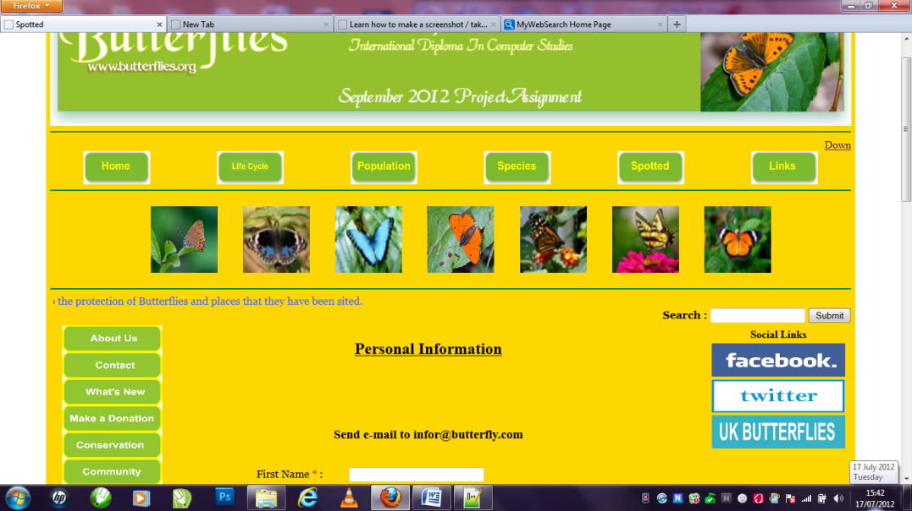
<!DOCTYPE html PUBLIC "-//W3C//DTD XHTML 1.0 Transitional//EN" "http://www.w3.org/TR/xhtml1/DTD/xhtml1-transitional.dtd">
<html xmlns="http://www.w3.org/1999/xhtml">

<head><title> Spotted </title></head>

<body>

<table width="800" align="center" Cellpadding="3" cellspacing = "3" bgcolor="#FFD700" border ="0">
<tr>
<td width="1200" height="180" align ="center"><table width="1000" Cellspacing="3" cellpadding="3">
<tr height="180" align="center"><img src = "../Images/banner4.JPG" width="1200" height="180"/></td>
</tr>
</table>
<hr color ="Green">
<div align ="right">
<a href = "#Down" valign ="top" align ="right">Down </a>
<div>

<table width = "1200" border="0" cellspacing="0" cellpadding="0" bgcolor ="">
<tr>
<td align="center"><a href ="../Index.html"><img src ="../Bottons/Home1.JPG" Width ="100" height ="50"/></a></td>
<td align="center"><a href ="Lifecircle.html"><img src ="../Bottons/Lifecircle.JPG" Width ="100" height ="50"/></a></td>
<td align="center"><a href ="Population.html"><img src ="../Bottons/Population.JPG" Width ="100" height ="50"/></a></td>
<td align="center"><a href ="Species.html"><img src ="../Bottons/Species.JPG" Width ="100" height ="50"/></a></td>
<td align="center"><a href ="Spotted.html"><img src ="../Bottons/Spotted.JPG" Width ="100" height ="50"/></a></td>
<td align="center"><a href ="Links.html"><img src ="../Bottons/Links.JPG" Width ="100" height ="50"/></a></td>
</tr>
</table cellpadding = "0" cellspacing ="0" >
<hr color ="Green" valign ="top">
<table Cellspacing="0" Cellpadding ="15" align ="center" bgcolor ="" width ="1000">
<tr>
<td>
<td height="100" align="center" valign="middle"><img src = "../Images/butter.JPG" width="100" height="100"/></td>
<td height="100" align="center" valign="middle"><img src = "../Images/butterfly1.JPG" width="100" height="100"/></td>
<td height="100" align="center" valign="middle"><img src = "../Images/Butterfly2.JPG" width="100" height="100"/></td>
<td height="100" align="center" valign="middle"><img src = "../Images/btfly.JPG" width="100" height="100"/></td>
<td height="100" align="center" valign="middle"><img src = "../Images/Butterfly3.JPG" width="100" height="100"/></td>
<td height="100" align="center" valign="middle"><img src = "../Images/butterfly4.JPG" width="100" height="100"/></td>
<td height="100" align="center" valign="middle"><img src = "../Images/butterfly5.JPG" width="100" height="100"/></td>
</tr>
</table>
<hr color ="Green" />

<table width="1195" border="0" cellspacing="0" cellpadding="0" bgcolor ="#FFD700" >
<tr>
<td align="center"><marquee behavior="scroll">
<font face="Georgia, Times New Roman, Times, serif"><font color="#3366FF">This website is dedicated to the protection of Butterflies and places that they have been sited.
</font></font>
</marquee></td>
</tr>

<tr>
<td width="285" cellspacing ="0" cellpadding="0" align = "right"><form id="form1" name="form1" method="post" action="">
<b><font face="Georgia, Times New Roman, Times, serif">Search : </font></b>
<input type="text" name="textfield" />
<input type="submit" name="Submit" value="Submit" />
</form></td>
</tr>
</table>

<table width="1195" bgcolor="" align="center" height="1000" valign = "top" border ="0" >
<tr>
<td width="125" valign ="top" border = "0">
<table width = "5" align ="center" cellspacing ="0" cellpadding="0" valign ="top" border ="0">
<tr><td width ="5" height ="10"><img src ="../Bottons/Aboutus.JPG" Width ="150" height ="40"/></td></tr>
<tr><td width ="5" height ="10"><img src ="../Bottons/Contact.JPG" Width ="150" height ="40"/></td></tr>
<tr><td width ="5" height ="10"><img src ="../Bottons/whatnew.JPG" Width ="150" height ="40"/></td></tr>
<tr><td width ="5" height ="10"><img src ="../Bottons/Donation.JPG" Width ="150" height ="40"/></td></tr>
<tr><td width ="5" height ="10" ><img src ="../Bottons/Coservation.JPG" Width ="150" height ="40"/></td></tr>
<tr><td width ="5" height ="10"><img src ="../Bottons/Community.JPG" Width ="150" height ="40"/></</td></tr>
<tr><td width ="5" height ="10"><img src ="../Bottons/Videos.JPG" Width ="150" height ="40"/></td></tr>
<tr><td width ="5" height ="10"><img src ="../Bottons/Gallary.JPG" Width ="150" height ="40"/></td></tr>
</table>
</td>

<td width="650" valign = "top" align = "left" border ="0" width = "1000"><div align="left"><table align ="lift" width = "" height ="" >
<form action="infor@butterfly.com:" method="post" enctype="text/plain">
<table width="" border="0" cellspacing="2" cellpadding="2" align="center">
<tr><td align ="center" colspan ="2"><h3>Send e-mail to infor@butterfly.com</h3></td></h3>
<tr><legend><u><h2 colspan ="2" align ="center">Personal Information</h2></u></legend></tr>
<tr>
<td width="133" height="47"><div align="left"><font face="Georgia, Times New Roman, Times, serif">
First Name <font color="#FF0000">*</font> :</font></div></td>
<td width="376"><div align="left">
<input type="text" size="30" maxsize="20" name="Input" value="" />
</div></td>
</tr>
<tr>
<td height="43"><div align="left"><font face="Georgia, Times New Roman, Times, serif">
Last Name <font color="#FF0000">*</font> :</font></div></td>
<td><div align="left">
<input type="text" size="30" maxsize="20" name="Input" value="" />
</div></td>
</tr>
<tr>
<td height="45"><div align="left"><font face="Georgia, Times New Roman, Times, serif">
Age <font color="#FF0000">*</font> :</font></div></td>
<td><div align="left">
<select name="age">
<option value="">(Please make a selection)</option>
<option value="1A"> Under 18</option>
<option value="1B"> 18-24 </option>
<option value="2B"> 25-29 </option>
<option value="3A"> 30-34 </option>
<option value="3B"> 35-39 </option>
<option value="4A"> 40-44 </option>
<option value="4B"> 45 and above </option>
</select>
</div></td>
</tr>
<tr>
<td height="43"><div align="left"><font face="Georgia, Times New Roman, Times, serif">
Address 1 <font color="#FF0000">*</font> :</font></div></td>
<td><div align="left">
<input type="text" size="30" maxsize="20" name="Input" value="" />
</div></td>
</tr>
<tr>
<td height="41"><div align="left"><font face="Georgia, Times New Roman, Times, serif">
Address 2 :</font></div></td>
<td><div align="left">
<input type="text" size="30" maxsize="20" name="Input" value="" />
</div></td>
</tr>
<tr>
<td height="39"><div align="left"><font face="Georgia, Times New Roman, Times, serif">
Country <font color="#FF0000">*</font> :</font></div></td>
<td><div align="left">
<select name="country">
<option value="">(Please make a selection)</option>
<option value="AF"> Afghanistan</option>
<option value="AL"> Albania</option>
<option value="DZ"> Algeria</option>
<option value="AS"> American Samoa</option>
<option value="AD"> Andorra</option>
<option value="AO"> Angola</option>
<option value="AI"> Anguilla</option>
<option value="AQ"> Antarctica</option>
<option value="AG"> Antigua</option>
<option value="AR"> Argentina</option>
<option value="AM"> Armenia</option>
<option value="AW"> Aruba</option>
<option value="AU"> Australia</option>
<option value="AT"> Austria</option>
<option value="AZ"> Azerbaijan</option>
<option value="BS"> Bahamas</option>
<option value="BH"> Bahrain</option>
<option value="BD"> Bangladesh</option>
<option value="BB"> Barbados</option>
<option value="BY"> Belarus</option>
<option value="BE"> Belgium</option>
<option value="BZ"> Belize</option>
<option value="BJ"> Benin</option>
<option value="BM"> Bermuda</option>
<option value="BT"> Bhutan</option>
<option value="BO"> Bolivia</option>
<option value="BA"> Bosnia</option>
<option value="BW"> Botswana</option>
<option value="BV"> Bouvet Island</option>
<option value="BR"> Brazil</option>
<option value="IO"> British Indian Ocean Territory</option>
<option value="VG"> British Virgin Islands</option>
<option value="BN"> Brunei</option>
<option value="BG"> Bulgaria</option>
<option value="BF"> Burkina Faso</option>
<option value="BI"> Burundi</option>
<option value="KH"> Cambodia</option>
<option value="CM"> Cameroon</option>
<option value="CA"> Canada</option>
<option value="CV"> Cape Verde</option>
<option value="KY"> Cayman Islands</option>
<option value="CF"> Central African Republic</option>
<option value="TD"> Chad</option>
<option value="CL"> Chile</option>
<option value="CN"> China</option>
<option value="CX"> Christmas Island</option>
<option value="CC"> Cocos (Keeling) Islands</option>
<option value="CO"> Colombia</option>
<option value="KM"> Comoros</option>
<option value="CG"> Congo</option>
<option value="CK"> Cook Islands</option>
<option value="CR"> Costa Rica</option>
<option value="CI"> Cote D'Ivoire</option>
<option value="HR"> Croatia</option>
<option value="CU"> Cuba</option>
<option value="CY"> Cyprus</option>
<option value="CZ"> Czech Republic</option>
<option value="CD"> Democratic Republic Of The Congo</option>
<option value="DK"> Denmark</option>
<option value="DJ"> Djibouti</option>
<option value="DM"> Dominica</option>
<option value="DO"> Dominican Republic</option>
<option value="EC"> Ecuador</option>
<option value="EG"> Egypt</option>
<option value="SV"> El Salvador</option>
<option value="GQ"> Equatorial Guinea</option>
<option value="ER"> Eritrea</option>
<option value="EE"> Estonia</option>
<option value="ET"> Ethiopia</option>
<option value="FK"> Falkland Islands</option>
<option value="FO"> Faroe Islands</option>
<option value="FJ"> Fiji</option>
<option value="FI"> Finland</option>
<option value="FR"> France</option>
<option value="GF"> French Guiana</option>
<option value="PF"> French Polynesia</option>
<option value="TF"> French Southern Territories</option>
<option value="GA"> Gabon</option>
<option value="GM"> Gambia</option>
<option value="GE"> Georgia</option>
<option value="DE"> Germany</option>
<option value="GH"> Ghana</option>
<option value="GI"> Gibraltar</option>
<option value="GR"> Greece</option>
<option value="GL"> Greenland</option>
<option value="GD"> Grenada</option>
<option value="GP"> Guadeloupe</option>
<option value="GU"> Guam</option>
<option value="GT"> Guatemala</option>
<option value="GN"> Guinea</option>
<option value="GW"> Guinea-Bissau</option>
<option value="GY"> Guyana</option>
<option value="HT"> Haiti</option>
<option value="HM"> Heard And Mcdonald Islands</option>
<option value="HN"> Honduras</option>
<option value="HK"> Hong Kong</option>
<option value="HU"> Hungary</option>
<option>Others</option>
</select>
</div></td>
</tr>
<tr>
<td height="40"><div align="left"><font face="Georgia, Times New Roman, Times, serif">
Zipcode <font color="#FF0000">*</font> :</font></div></td>
<td><div align="left">
<input type="text" size="20" maxsize="20" name="Input" value="" />
</div></td>
</tr>
<tr>
<td height="37"><div align="left"><font face="Georgia, Times New Roman, Times, serif">
Email address <font color="#FF0000">*</font> :</font></div></td>
<td><div align="left">
<input type="text" size="30" maxsize="20" name="Input" value="" />
</div></td>
</tr>
<tr>
<td>
</form></div><br/>
<br/>
<div align ="center"><tr><td>
<td><legend><h3><u> Species Spotted Details </u></h3></Legend></td>
<tr>
<td height="43"><div align="left"><font face="Georgia, Times New Roman, Times, serif">
Species Type:
<td><div align="left">
<input type="text" name="comment" value="Name of Species Spotted" size="50" height = "200"/><br/>
</div></td>
<br/>
<tr>
<td height="43"><div align="left"><font face="Georgia, Times New Roman, Times, serif">
Date and Time Spotted: <td><div align="left"><input type="datetime" name="Time Spooted" value = "Day/Month/Year" />
</div></td></tr>

<tr>
<td height="43"><div align="left"><font face="Georgia, Times New Roman, Times, serif">
<form action="form_action.asp" accept="image/gif, image/jpeg"><br/>
Load Image of Spotted Species: <td><div align="left"><input type="file" name="pic" id="pic" /><br />
</div></td></tr>
<tr><td colspan ="2"><div align="left">
<label > What country do you spot the new species of butterfly? </label><br/>
</div></td></tr>
<tr>
<td height="43"><div align="left"><font face="Georgia, Times New Roman, Times, serif">
Country <font color="#FF0000">*</font> :</font></div></td>
<td><div align="left">
<select name="country">
<option value="">(Please make a selection)</option>
<option value="AF"> Afghanistan</option>
<option value="AL"> Albania</option>
<option value="DZ"> Algeria</option>
<option value="AS"> American Samoa</option>
<option value="AD"> Andorra</option>
<option value="AO"> Angola</option>
<option value="AI"> Anguilla</option>
<option value="AQ"> Antarctica</option>
<option value="AG"> Antigua</option>
<option value="AR"> Argentina</option>
<option value="AM"> Armenia</option>
<option value="AW"> Aruba</option>
<option value="AU"> Australia</option>
<option value="AT"> Austria</option>
<option value="AZ"> Azerbaijan</option>
<option value="BS"> Bahamas</option>
<option value="BH"> Bahrain</option>
<option value="BD"> Bangladesh</option>
<option value="BB"> Barbados</option>
<option value="BY"> Belarus</option>
<option value="BE"> Belgium</option>
<option value="BZ"> Belize</option>
<option value="BJ"> Benin</option>
<option value="BM"> Bermuda</option>
<option value="BT"> Bhutan</option>
<option value="BO"> Bolivia</option>
<option value="BA"> Bosnia</option>
<option value="BW"> Botswana</option>
<option value="BV"> Bouvet Island</option>
<option value="BR"> Brazil</option>
<option value="IO"> British Indian Ocean Territory</option>
<option value="VG"> British Virgin Islands</option>
<option value="BN"> Brunei</option>
<option value="BG"> Bulgaria</option>
<option value="BF"> Burkina Faso</option>
<option value="BI"> Burundi</option>
<option value="KH"> Cambodia</option>
<option value="CM"> Cameroon</option>
<option value="CA"> Canada</option>
<option value="CV"> Cape Verde</option>
<option value="KY"> Cayman Islands</option>
<option value="CF"> Central African Republic</option>
<option value="TD"> Chad</option>
<option value="CL"> Chile</option>
<option value="CN"> China</option>
<option value="CX"> Christmas Island</option>
<option value="CC"> Cocos (Keeling) Islands</option>
<option value="CO"> Colombia</option>
<option value="KM"> Comoros</option>
<option value="CG"> Congo</option>
<option value="CK"> Cook Islands</option>
<option value="CR"> Costa Rica</option>
<option value="CI"> Cote D'Ivoire</option>
<option value="HR"> Croatia</option>
<option value="CU"> Cuba</option>
<option value="CY"> Cyprus</option>
<option value="CZ"> Czech Republic</option>
<option value="CD"> Democratic Republic Of The Congo</option>
<option value="DK"> Denmark</option>
<option value="DJ"> Djibouti</option>
<option value="DM"> Dominica</option>
<option value="DO"> Dominican Republic</option>
<option value="EC"> Ecuador</option>
<option value="EG"> Egypt</option>
<option value="SV"> El Salvador</option>
<option value="GQ"> Equatorial Guinea</option>
<option value="ER"> Eritrea</option>
<option value="EE"> Estonia</option>
<option value="ET"> Ethiopia</option>
<option value="FK"> Falkland Islands</option>
<option value="FO"> Faroe Islands</option>
<option value="FJ"> Fiji</option>
<option value="FI"> Finland</option>
<option value="FR"> France</option>
<option value="GF"> French Guiana</option>
<option value="PF"> French Polynesia</option>
<option value="TF"> French Southern Territories</option>
<option value="GA"> Gabon</option>
<option value="GM"> Gambia</option>
<option value="GE"> Georgia</option>
<option value="DE"> Germany</option>
<option value="GH"> Ghana</option>
<option value="GI"> Gibraltar</option>
<option value="GR"> Greece</option>
<option value="GL"> Greenland</option>
<option value="GD"> Grenada</option>
<option value="GP"> Guadeloupe</option>
<option value="GU"> Guam</option>
<option value="GT"> Guatemala</option>
<option value="GN"> Guinea</option>
<option value="GW"> Guinea-Bissau</option>
<option value="GY"> Guyana</option>
<option value="HT"> Haiti</option>
<option value="HM"> Heard And Mcdonald Islands</option>
<option value="HN"> Honduras</option>
<option value="HK"> Hong Kong</option>
<option value="HU"> Hungary</option>
<option>Others</option>
</select>
</div></td></tr>

<tr>
<td colspan ="2"><div align="left">
<label> What marks did it have on it's wings? </label>
</div></td></tr>
<br/>
<tr>
<td height="43"><div align="left"><font face="Georgia, Times New Roman, Times, serif">
Markings <font color="#FF0000">*</font> :</font></div></td>
<td><div align="left">
<select>
<option value="No Markings">No Markings</option>
<option value="Spots">Spots</option>
<option value="Spots & Markings">Spots & Markings</option>
<option value="Strips">Stripes</option>
</select>
</div></td></tr>
<tr>
<td height="43"><div align="left"><font face="Georgia, Times New Roman, Times, serif">
Color type: <font color="#FF0000">*</font> :</font></div></td>
<td><div align="left">
<select>
<option value="blue">Blue</option>
<option value="green">Green</option>
<option value="White">White</option>
<option value="Yellow">Yellow</option>
<option value="Red">Red</option>
<option value="Pink">Pink</option>
<option value="Brown">Brown</option>
<option value="other Colors">Other Colors</option>
</select>
</div></td></tr>
<tr>
<td height="43"><div align="left"><font face="Georgia, Times New Roman, Times, serif">
Details of Species/Type Spotted:</div></td>
<td><div align="left">
<textarea rows="2" cols="20" maxlength ="300" border ="1" > (Your entry must be no more than 300 characters long) </textarea>
</div></td>
<br>
</form>
<tr>
<td height="43"><div align="left">
<input type="submit" value="Send">
<input type="reset" value="Reset">
<td height="150" colspan="3" align="center">
<div align="center">
<p align="left"><i><font face="Georgia, Times New Roman, Times, serif"></td></tr>
</div>
</div></td></tr>
<tr>
<td colspan ="2"><div align="left">
Would you like to receive monthly Newsletters on new discoveries and new spotted sites guides?</font></i></p>
<div align="left">
<input type="radio" name="addtolist" value="yes" checked="checked"/>
<i><font face="Georgia, Times New Roman, Times, serif">
Send me a Newsletter every month.</font></i><br>
<input type="radio" name="addtolist" value="no"/><i><font face="Georgia, Times New Roman, Times, serif">
No thanks</font></i></br>
</div></div></td></tr>
</form>
</tr>
</table></td>
<td width="200" height="450" align="right" cellpadding = "0" cellspacing ="0" border ="1" valign ="top"><table>
</td>
<tr><th> Social Links</th></tr>
<tr><td><a href ="https://www.facebook.com/pages/Butterfly-Conservation/109223272437586" target = "_blank"><img src ="../Bottons/facebook.JPG" Width ="200" height ="50" align ="center" /></a></td></tr>
<tr><td><a href =" https://twitter.com/savebutterflies/status/217648895856082946" target ="_blank"><img src ="../Bottons/twitter.JPG" Width ="200" height ="50" align ="center"/></a></td></tr>
<tr><td><a href="http://www.ukbutterflies.co.uk/index.php" Target ="_blank"><img src ="../Bottons/ukbutterflies.JPG" Width ="200" height ="50" align ="center"/></a></td></tr>
</table>
</td>
</tr>
</table>
<a name ="Down" ></a><a href = "#top"> Back to the top</a>
<hr color = "green">
<table align="center" cellpadding = "0" cellspacing ="0"><tr><td valign ="bottom" align ="center" > All content copyright &copy; 2012, NCC Student Abdul Bunduk Kamara</td></tr></table>

</body>

</html>

Links Page Screen Shot
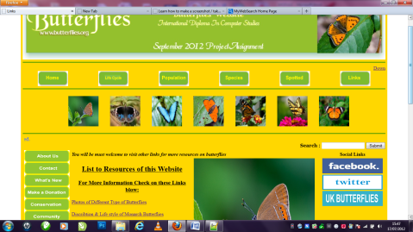
- This page is a page that gives the user more links to other website for butterfly information and resources.

<!DOCTYPE html PUBLIC "-//W3C//DTD XHTML 1.0 Transitional//EN" "http://www.w3.org/TR/xhtml1/DTD/xhtml1-transitional.dtd">
<html xmlns="http://www.w3.org/1999/xhtml">

<head><title> Links </title></head>
<body>
<table width="800" align="center" Cellpadding="3" cellspacing = "3" bgcolor="#FFD700" border ="0">
<tr>
<td width="1200" height="180" align ="center"><table width="1000" Cellspacing="3" cellpadding="3">
<tr height="180" align="center"><img src = "../Images/banner4.JPG" width="1200" height="180"/></td>
</tr>
</table>
<hr color ="Green">
<div align ="right">
<a href = "#Down" valign ="top" align ="right">Down </a>
<div>

<table width = "1200" border="0" cellspacing="0" cellpadding="0" bgcolor ="">
<tr>
<td align="center"><a href ="../Index.html"><img src ="../Bottons/Home1.JPG" Width ="100" height ="50"/></a></td>
<td align="center"><a href ="Lifecircle.html"><img src ="../Bottons/Lifecircle.JPG" Width ="100" height ="50"/></a></td>
<td align="center"><a href ="Population.html"><img src ="../Bottons/Population.JPG" Width ="100" height ="50"/></a></td>
<td align="center"><a href ="Species.html"><img src ="../Bottons/Species.JPG" Width ="100" height ="50"/></a></td>
<td align="center"><a href ="Spotted.html"><img src ="../Bottons/Spotted.JPG" Width ="100" height ="50"/></a></td>
<td align="center"><a href ="Links.html"><img src ="../Bottons/Links.JPG" Width ="100" height ="50"/></a></td>
</tr>
</table cellpadding = "0" cellspacing ="0" >
<hr color ="Green" valign ="top">
<table Cellspacing="0" Cellpadding ="15" align ="center" bgcolor ="" width ="1000">
<tr>
<td>
<td height="100" align="center" valign="middle"><img src = "../Images/butter.JPG" width="100" height="100"/></td>
<td height="100" align="center" valign="middle"><img src = "../Images/butterfly1.JPG" width="100" height="100"/></td>
<td height="100" align="center" valign="middle"><img src = "../Images/Butterfly2.JPG" width="100" height="100"/></td>
<td height="100" align="center" valign="middle"><img src = "../Images/btfly.JPG" width="100" height="100"/></td>
<td height="100" align="center" valign="middle"><img src = "../Images/Butterfly3.JPG" width="100" height="100"/></td>
<td height="100" align="center" valign="middle"><img src = "../Images/butterfly4.JPG" width="100" height="100"/></td>
<td height="100" align="center" valign="middle"><img src = "../Images/butterfly5.JPG" width="100" height="100"/></td>
</tr>
</table>
<hr color ="Green" />

<table width="1195" border="0" cellspacing="0" cellpadding="0" bgcolor ="#FFD700" >
<tr>
<td align="center"><marquee behavior="scroll">
<font face="Georgia, Times New Roman, Times, serif"><font color="#3366FF">This website is dedicated to the protection of Butterflies and places that they have been sited.
</font></font>
</marquee></td>
</tr>
<tr>
<td width="285" cellspacing ="0" cellpadding="0" align = "right"><form id="form1" name="form1" method="post" action="">
<b><font face="Georgia, Times New Roman, Times, serif">Search : </font></b>
<input type="text" name="textfield" />
<input type="submit" name="Submit" value="Submit" />
</form></td>
</tr>
</table>

<table width="1195" bgcolor="" align="center" height="1000" valign = "top" border ="0" >
<tr>
<td width="125" valign ="top">
<table width = "5" align ="center" cellspacing ="0" cellpadding="0" valign ="top">
<tr><td width ="5" height ="10"><img src ="../Bottons/Aboutus.JPG" Width ="150" height ="40"/></td></tr>
<tr><td width ="5" height ="10"><img src ="../Bottons/Contact.JPG" Width ="150" height ="40"/></td></tr>
<tr><td width ="5" height ="10"><img src ="../Bottons/whatnew.JPG" Width ="150" height ="40"/></td></tr>
<tr><td width ="5" height ="10"><img src ="../Bottons/Donation.JPG" Width ="150" height ="40"/></td></tr>
<tr><td width ="5" height ="10" ><img src ="../Bottons/Coservation.JPG" Width ="150" height ="40"/></td></tr>
<tr><td width ="5" height ="10"><img src ="../Bottons/Community.JPG" Width ="150" height ="40"/></</td></tr>
<tr><td width ="5" height ="10"><img src ="../Bottons/Videos.JPG" Width ="150" height ="40"/></td></tr>
<tr><td width ="5" height ="10"><img src ="../Bottons/Gallary.JPG" Width ="150" height ="40"/></td></tr>
</table>
</td>
<td width="650" valign = "top" align = "left" ><table border = "0" width ="800">
<tr><th colspan ="2"><strong><em>You will be must welcome to visit other links for more resources on butterflies </em><strong></th></tr>
<tr valign ="top" width ="300" height ="300">
<td width ="400" height ="400" >
<u><h2 align ="center"> List to Resources of this Website</h2></u>
<u><h3 align ="center"> For More Information Check on these Links blow:</h3></u>
<u><a href="http://www.eurobutterflies.com/species_pages/palaemon.htm">Photos of Different Type of Butterflies </a></u><br>
<br>
<u><a href="http://www.monarch-butterfly.com/monarch-migration.html" Target ="_blank" >Discribtion & Life style of Monarch Butterflies</a></u><br>
<br>
<u><a href="http://butterflywebsite.com/gallery/index.cfm" Target ="_blank">A Gallery of Various Species of Butterflies</a></u><br>
<br>
<u><a href="http://www.butterfly-conservation.org/text/20/join_butterfly_conservation.html"Target ="_blank" >A website that Help the Conservation of Butterflies</a></u><br>
<br>
<u><a href="http://www.ukbutterflies.co.uk/index.php" Target ="_blank">Show Case of UK Butterflies</a></u><br>
<br>
<u><a href="http://www.nhc.ed.ac.uk/index.php?page=24.25.26" Target ="_blank">A Special Website for Enduction on Butterfies </a></u><br>
<br>
<u><a href="http://www.wwb.co.uk/shop/index.php/cPath/26" Target ="_blank">A Shopping Website for Butterflies</a></u><br>
<br>
<u><a href="http://kidsbutterfly.org/coloringpages" Target ="_blank">A Website that Help's Children to Learn About Butterflies</a></u><br>
<br>
<u><a href="http://www.butterfliesandmoths.org/checklists?species_type=All&tid=Any" target ="_blank">A Website show and discribe various type of Species of Butterflies</a></u>

</td>
<td height="400" width ="400" align="center" valign="top"><img src = "../Images/butter.JPG" width="400" height="400"/></td>
</tr >
<tr>
<td width = "400" height="400" valign ="top" align ="center"><img src ="../Images/flies.JPG" Width ="400" height ="400"/></td>
<td width = "400" height="400" valign ="top" align ="center"><img src ="../Images/fly.JPG" Width ="400" height ="400"/></td>
</tr>
<tr>
<td align="center" colspan ="2"><marquee behavior="scroll">
<font face="Georgia, Times New Roman, Times, serif"><font color="#3366FF"><img src = "../Images/safe.JPG" width="600" height="100"/></font></font>
</marquee></td>
</tr>
</table></td>

<td width="300" height="450" align="right" cellpadding = "0" cellspacing ="0" border ="1" valign ="top"><table>
</td>
<tr><th> Social Links</th></tr>
<tr><td><a href ="https://www.facebook.com/pages/Butterfly-Conservation/109223272437586" target = "_blank"><img src ="../Bottons/facebook.JPG" Width ="200" height ="50" align ="center" /></a></td></tr>
<tr><td><a href =" https://twitter.com/savebutterflies/status/217648895856082946" target ="_blank"><img src ="../Bottons/twitter.JPG" Width ="200" height ="50" align ="center"/></a></td></tr>
<tr><td><a href="http://www.ukbutterflies.co.uk/index.php" Target ="_blank"><img src ="../Bottons/ukbutterflies.JPG" Width ="200" height ="50" align ="center"/></a></td></tr>
</table>
</td>
</tr>
</table>
<a name ="Down" ></a><a href = "#top"> Back to the top</a>
<hr color = "green">
<table align="center" cellpadding = "0" cellspacing ="0"><tr><td valign ="bottom" align ="center" > All content copyright &copy; 2012, NCC Student Abdul Bunduk Kamara</td></tr></table>

</body>

</html>

Task 5
REPORT
DATE: 26 September 2012

TO: Butterfly Web Site.

FROM: Abdul Bundu Kamara

Report Title: Report on Butterfly Web Site
Introduction: - in this task am going to describe the various skills and techniques that I used to developed the Butterfly website and ways that the website can furtherbe upgraded. I will give various key suggestions such as:
- Strong & Weak aspects
- Analysis of Design Principle & Technology
- Accessibility of the Website
- Improvement with CSS (Cascading Style Sheet).

Main Objectives: - My main objectives in this task are to analyses and highlight:
- the strong and weak aspect of the website
- Suggesting improvements and propose ideas for further developments.
- A clear analysis of basic web design principle and technology that I used to develop the web site.
- A discussion on the accessibility of the web site.
- How the web site could be improve through the use of CSS (Cascading Style Sheet).
Expected Outcomes: - on finishedthis report analyses, I will expect to have made it clear, as to how futureimprovement to my website could be develop or upgrade.
- The strong & weak aspects

- The Strong Aspects of my web site is the design layout of the pages I have created already table rows position on the both lift and right side of the pages for future development or upgrade by making available button to be linked to new pages that may be created in the future. I have also create a space in the right of each page for other external links like the example linked Facebook, Twitter and UK Butterfly website on the right side of each page.

- Main Strength:
- Uniformity of the web pages (Consistency):-I made the pages to have the same layout, background colours and font properties and all other attributes are the same.

- Use of Alternative text for images &videos: - I included an alternative text for the video in case, it cannot be display in a particular browser the text will be display for the user to know the reason why the media is not displayed.
- The Ease of Use of the Website: - my website is very easy to navigate through and I maintain a unique layout to all pages of the website using table rows and table data to control the positions of objects in the pages.
- Usage of flatten Video & Images:- I used a video format to support the playing of my video on most of the browses and have an alternative text to give feedback when video is not support by a browser.

- The Weak Aspects
- Use of Tables: While using evocative table rows and table data to enhance the layout of my website, I realised that because of limited usage of div with no CSS made it difficult to align and to make a clear positioning layout of my pages.

- Appearance on Different Browsers: by not using CSS my website pages may not be support by most of the browsers or may not give the exact layout that I have designed.

- Interactive: website supposes to be interactive on all the pages for a more user friendly environment but because of no database attachment this makes it difficult.

- Accessibility of the website

- I used HTML tables and forms to guide my images and other object in the site, by labelling the table row, table data and forms with attributes to make its appearance simple and clear.

- I have made a clear and precise layout of my website for easy navigation to help users find their way in and out of the web links targeted to a blank page which will keep the user in website.

- I have set the font size to be readable to all users of the website the font type is also worked on for users to be able to select type of font they will like to select from the browsers.

- Text are the core of any website because its enable the user to understand the content of the page, I made the text easy for readers to be able to enjoy reading or visiting the site.
- Suggesting Improvements
- I will like to improve my web site basically on the layout of the pages by bring in CSS and the use of more of div to my tables to position data and images that I will place in the pages to allow the website to be able to be viewed on different browsers.
- I would like to place a respond to the feedback of the user and make it possible by JavaScript for the website to be more dynamic.
- I will need a database to handle all information and interactive of the users of the website.

- Cascading Style Sheet (CSS)
- Sizing of the File:by using CSS the website size will be reduce and this will ensure fast downloading and opening of the page.

- User Accessibility: CSS usage in the website will enable user friendly environment by making the website more accessible and separating content of the web pages to allow ease of use for navigation which will make the website attractive.

- Flexibility of CSS: With CSS style specified or declared are global and affects tags where they are called.

- Maintenance With CSS: because CSS are declared globally with common position in place it is easy to make correction of any error in the site.
(Robbins, 2008)

References
http://www.eurobutterflies.com/species_pages/palaemon.html
http://www.monarch-butterfly.com/monarch-migration.html
http://butterflywebsite.com/gallery/index.cfm
http://www.butterfly-conservation.org/text/20/join_butterfly_conservation.html
http://www.ukbutterflies.co.uk/index.php
http://www.nhc.ed.ac.uk/index.php?page=24.25.26
http://www.wwb.co.uk/shop/index.php/cPath/26
http://kidsbutterfly.org/coloringpages
http://www.butterfliesandmoths.org/checklists?species_type=All&tid=Any
Bibliography
Robbins, J. N. (2008). Learning Web Design. Accra: O'REILLY.
http://www.w3.org

